Food-Pass-System (F.P.S.): A Python-Based Smart Canteen Management System for Students, Parents, and Canteen Staff

Problem Statement:
Traditional school canteen systems often rely heavily on cash transactions. While this method is simple, it creates several problems for students, parents, and canteen staff. Students may lose their money, overspend their allowance, or experience delays due to long transaction lines during break times. Parents also have limited visibility over how their children spend their allowance inside the school canteen. Meanwhile, canteen staff struggle to track unpaid balances, remind students about debts, and maintain organized transaction records.
Many schools lack a centralized digital system connecting students, parents, and canteen staff. This absence can result in inefficient operations, inaccurate records, and weak financial oversight.
The Food-Pass-System (F.P.S.) was developed to address these issues by introducing a role-based smart canteen management system using Python programming. The project aims to modernize school canteen operations by implementing digital balance management, transaction tracking, reminder systems, and controlled borrowing features.
The project is highly relevant in both classroom and real-world settings because it demonstrates practical applications of programming, database organization, CRUD operations, and financial management systems. It also encourages the use of technology to improve efficiency and communication between students, parents, and school staff.

Project Overview:
The Food-Pass-System (F.P.S.) is a Python-based application designed to function as a smart canteen card system. The application allows students to purchase food digitally using a balance stored in their account. Parents can monitor balances, deposit money, and repay student debts, while canteen staff can manage reminders and account information.
The system uses a centralized dictionary-based database structure to store and manage user information such as balances, transaction history, reminders, and loan or tab amounts.
The project demonstrates important concepts in Python programming and data management, including:
- Dictionary-based databases
- CRUD (Create, Read, Update, Delete) operations
- Input validation and error handling
- Role-based access systems
- Transaction management
- Loan and balance tracking
- Data organization and storage
The project is relevant to Python programming because it applies core programming concepts such as functions, loops, conditionals, lists, dictionaries, and exception handling. It also demonstrates basic database concepts through structured data storage.

General Objective:
To develop a smart canteen management system that improves transaction efficiency, financial monitoring, and communication between students, parents, and canteen staff.

S.M.A.R.T. Objectives:
Specific:
Develop a role-based smart canteen system with student, parent and staff functionalities.

Measurable:
Successfully implement account management, transaction tracking, and C.R.U.D.-based reminders.

Achievable:
Use Python programming to create a working prototype system.

Relevant:
Address issues involving cash handling, budgeting, and canteen management.

Time-Bound:
Complete the prototype system within academic project deadline.

Methodology:
The project follows a prototype-based development approach. The system was first designed as a console-based application to test the logic and structure of the smart canteen system before possible expansion into an enhanced platform.
The system was developed in Python for its readability, flexibility, and suitability for beginner-to-intermediate software development.

Flowchart:
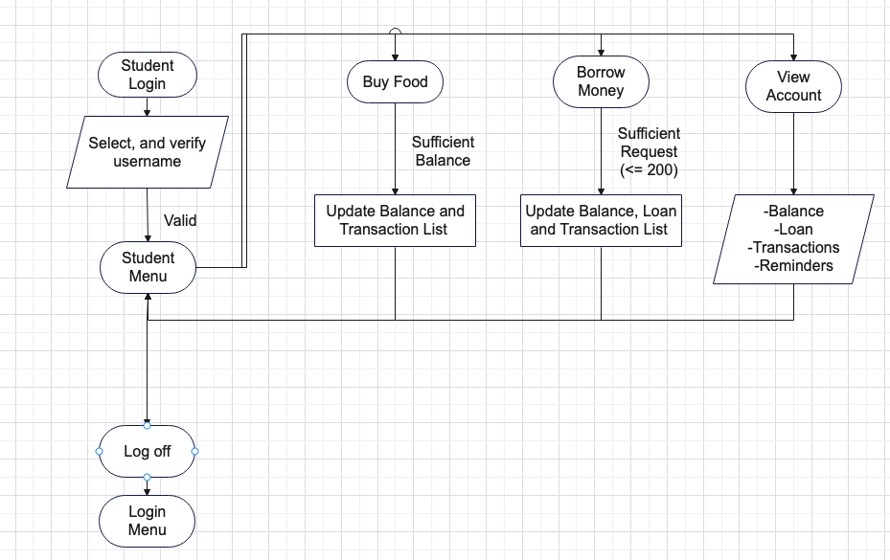
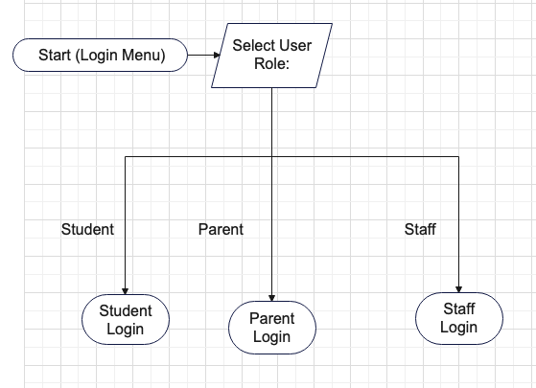

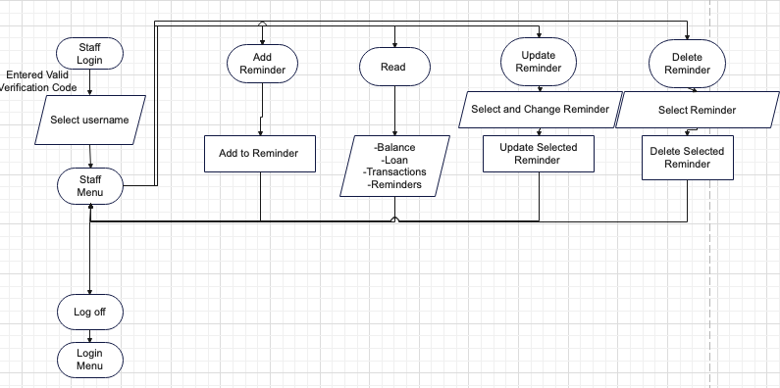
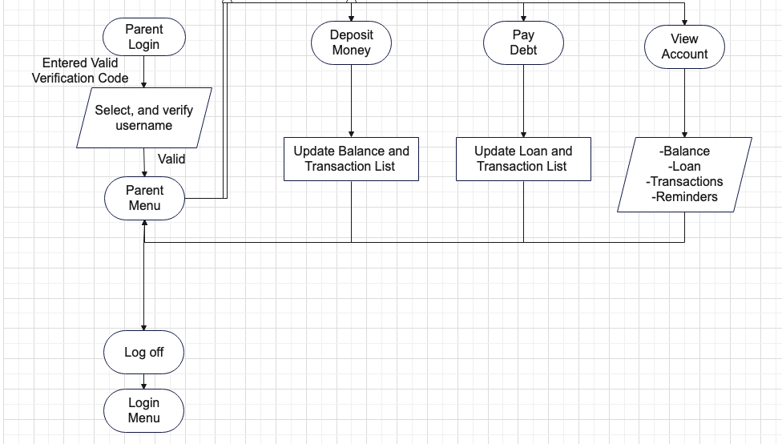

 | 1 | 2 | 3 | 4 (Split)
Myles | Submission, Paper | Flowchart | Student Code | Submission
Kim | Paper | Paper | Parent/Staff Code | N/A
Chelsea | Paper | Flowchart | Coordinating Code | N/A
Sachi | Paper | Paper | Login Code | N/A
Xed | None | Paper | Parent/Staff Code | N/A

References:

Wikipedia contributors. (2026, May 3). Smart card. Wikipedia. https://en.wikipedia.org/wiki/Smart_card#:~:text=Smart%20cards%20can%20provide%20personal,on%20(SSO)%20within%20organizations.

GeeksforGeeks. (2025, July 23). What is Data Dictionary? GeeksforGeeks. https://www.geeksforgeeks.org/dbms/what-is-data-dictionary/

